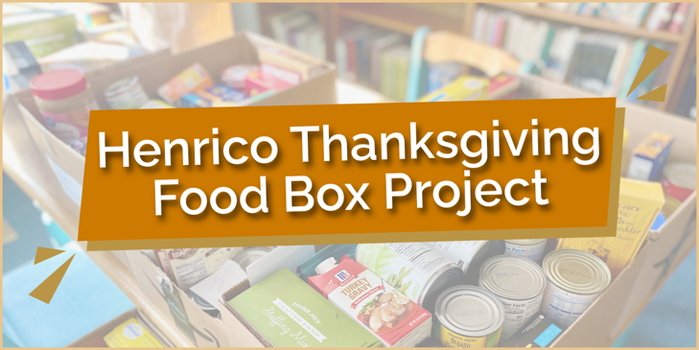
TUCKAHOE PRESBYTERIAN CHURCH
THANKSGIVING FOOD BOX PROGRAM 2025

It’s time once again to support the Henrico Thanksgiving Food Box Project!

Each year, this effort provides Thanksgiving meals for families and individuals served by the Henrico Department of Social Services. With rising food costs and ongoing economic challenges, many of our neighbors are experiencing food insecurity. Your gift of a food box can make it possible for a family to enjoy a holiday meal together. Consider partnering with your small group, family, or friends to donate a box. Flyers with item lists and group sign-up information are available in the Resource Center or online.
Please bring all food boxes to the Church Library by Thursday, November 20.

PLEASE NOTE:
ALL FOOD BOXES SHOULD FEED A FAMILY OF SIX.
NO FROZEN, FRESH OR PERISHABLE ITEMS PLEASE.
GIFT CARD FOR TURKEY OR HAM (ABOUT $20 - $25)

Suggested Items:
Canned Vegetables Stuffing Mix Peanut Butter
Canned Soup Potatoes, Instant Jelly
Canned Fruit Macaroni and Cheese Dessert Item
Canned Gravy Rolls Gift Card

PLEASE DROP OFF YOUR BOX IN THE CHURCH LIBRARY
BY THURSDAY, NOVEMBER 20
This is a great opportunity for your Committee, Group, or Family.
Boxes do not need to be decorated.
Contact Meg Packard (337-2081) or Kaye Keyes (360-7371)
if you have any questions.
Note: On the reverse is a sign-up sheet that can be used with your group or organization.
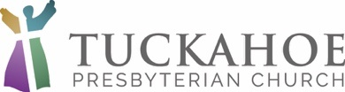
THANKSGIVING BOXES

CANNED VEGETABLES

CANNED SOUP

CANNED FRUIT

CANNED GRAVY

STUFFING MIX

POTATOES, INSTANT

MACARONI AND CHEESE

PEANUT BUTTER

PB & JELLY

DESSERT ITEM

GIFT CARD FOR TURKEY ($20-$25)

PURCHASE ENOUGH TO FEED A FAMILY OF 6
PLEASE, NO FROZEN OR PERISHABLE ITEMS
DELIVER BOXES TO THE CHURCH LIBRARY BY THURSDAY, NOVEMBER 20
CONTACTS: Meg Packard or Kaye Keyes

