TUCKAHOE PRESBYTERIAN CHURCH

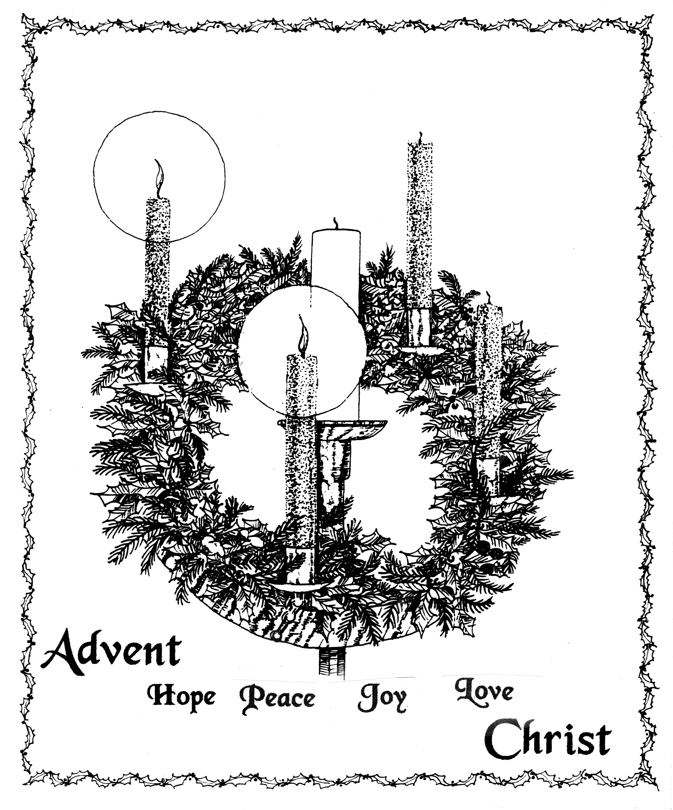
Service for the Lord’s Day
Called by God
to be the heart, voice, hands and feet of
Christ where the Spirit leads us.

December 9, 2018 Second Sunday of Advent
****************************************************************************
Welcome and Announcements

Music Meditation

Lighting of the Advent Wreath Barbara Luckett and Eric Johnson
…As we light our second Advent candle,
we pray for the holy peace of God.
Come now, O Child of Mary.
Come now, O Prince of Peace.

*Processional Hymn “Come, Thou Long-Expected Jesus” No. 82

*Prayer of Confession
God of the future, you are coming in power to bring all nations under your rule. We confess that we have not expected your kingdom, for we live casual lives, ignoring your promised judgement. We accept lies as truth, exploit neighbors, abuse the earth, and refuse your justice and peace. In your mercy, forgive us. Grant us wisdom to welcome your way, and to seek things that will endure when Christ comes to judge the world....(silent confession)

*Assurance of Forgiveness

*Gloria Patri
Glory be to the Father, and to the Son, and to the Holy Ghost. As it was in the beginning, is now and ever shall be, world without end. Amen. Amen.

* The Passing of the Peace
The peace of our Lord Jesus Christ be with you all.
And also with you!
Prayer for Illumination

Old Testament Lesson Isaiah 40: 1 – 5, 21 - 31 Page 667
The word of the Lord
Thanks be to God.

AnthEM “Let All Creation Celebrate” Larson

Moments with the Children Linda Kurtz

HYMN “Let All Mortal Flesh Keep Silence” No. 347

Gospel LessON Luke 1: 26 - 38 Page 56
The word of the Lord.
Thanks be to God.

Sermon “First Advent” Sarah Dennis

SOLO “Mary Did You Know?” Greene

*Affirmation of Faith Adapted from the Confession of 1967, 9.18
God expressed love for all humankind through Israel, whom God chose
to be a covenant people
to serve him in love and faithfulness. When Israel was unfaithful,
God disciplined the nation with judgment and maintained the covenant
through prophets, priests, teachers,
and true believers.
These witnesses called all Israelites
to a destiny
in which they would serve God faithfully and become a light to the nations.
The same witnesses proclaimed
the coming of a new age,
and a true servant of God
in whom God’s purpose would be realized.

Prayers of the People and the Lord’s Prayer
Our Father, who art in heaven, hallowed be thy name, thy kingdom come, thy will be done, on earth as it is in heaven. Give us this day our daily bread; and forgive us our debts, as we forgive our debtors; and lead us not into temptation, but deliver us from evil. For thine is the kingdom, and the power, and the glory, forever. Amen.

Presentation of Gifts and Offerings

Offertory “O Come to Us, Emmanuel” Martin

*Doxology (to the tune of O Come, O Come Emmanuel, No. 88)
Praise God, from whom all blessings flow; praise him, all creatures here below; praise him above, ye heavenly hosts; praise Father, Son, and Holy Ghost. Rejoice! Rejoice! Emmanuel shall come to thee, O Israel.

*Prayer of Thanksgiving and Dedication

*Hymn “My Soul Cries Out with a Joyful Shout” No. 100

*Charge and Benediction

Postlude “Praise Ye the Lord of Hosts” Saint-Saens *************************************************************************

TODAY’S WORSHIP LEADERS
Sarah Dennis, Director of Christian Formation; Patrick Dennis, Pastor;
Linda Kurtz, Seminary Intern; Mark Cain, Director of Music Ministries;
Sarah Cothern, Assistant Director of Music Ministries;
Mary Chris Werner, Lay Reader; and Patrick Fabrie, Acolyte

ANNOUNCEMENTS AND CALENDAR

We are pleased to have you worship with us and sincerely hope our service inspires and challenges you. Join us during the fellowship time after worship for refreshments and a chance to get to know you! Please sign the Friendship Pads when they are passed in the pews. If you are visiting Tuckahoe for the first time, please see an usher in the narthex to receive a gift.

Childcare is provided during the worship hour for children infant through first grade. The Nursery in Room 104 is designed for infants through 23 months. Two and three year olds may be taken to Room 102. Children age 4 through 1st grades may be taken to Room 105 for childcare. Parents are responsible for picking up children from childcare at the conclusion of the service.

The flowers are given by Mary and Meagan McGee to the Glory of God and in celebration of Ann Darden’s 95th birthday. Nursery Helpers are Cara Fabrie, Pat Miller and Leslie Shimer. The After Church Fellowship time is hosted by Kathy Bauer. The sound technician is Callie Fabrie.

Pastoral Care Concerns:
Hospitalized and recovering– Gloria Morton and Bob Smith

Session has called a Congregational Meeting for next Sunday, December 16th, following worship, to hear a report from the Nominating Committee.

This week, and throughout the month, we collect non-perishable food items for the Henrico County foodbank, The Lamb’s Basket. Remember as we enter and complete the Holiday Season, as well as the cold Winter months, Lamb's Basket clients have three important things to spend their available monetary resources on, heat, medicines/medical expenses and food. Your donations truly help with the third choice! And, if you want to think about volunteering at Lamb's Basket, please talk to Fred Bower, Marlene Austin or Robins Buck. If you are interested in readying "The Wooly News", the fourth quarter newsletter, please follow this link: http://www.lambsbasket.org/wooly-news---november-2018.php

Advent is a time of preparation and anticipation. The coming of Jesus invites us to slow down and anticipate the season. Join us as we together read through Walter Brueggemann’s advent devotion, Celebrating Abundance. Through his book, we will “train our eyes to see through the rough stable, the adolescent mother, and the anxious escape to Egypt, so we can see in that poverty and powerlessness the wonder of God's abundant life and grace coming down to dwell among us.” Sermons, Tuesday Prayer Group and Sunday School classes, if they choose, will use this book to prepare for Christmas. We want all of Tuckahoe to celebrate Abundance with us, so we will provide copies of the book so you can read along with us, see through different eyes and celebrate the joyful and abundant life Christ gives to us. The books are in the Resource Center between the narthex and Duntreath Hall.

Please note…tomorrow is the last day for Christmas Poinsettias orders to be placed. They must be in the church office by Monday, December 10th in order to be included in the flower order and listed in the bulletin insert!

Join us this Wednesday night for our mid-week meal and programming. The meal begins at 6:00 p.m. in Duntreath Hall. Cooking Team #2 will serve a catered meal from The Grapevine Restaurant. The menu is Fettucine Alfredo (with or without chicken), salad, bread and dessert. Come enjoy an evening of Christmas music favorites. The Sleepy Hollow Bluegrass Band will perform some of your favorite Christmas songs bluegrass style! The KMD children’s handbell group will not rehearse again until after the New Year. Please sign up for dinner on the friendship pad this morning or on the event block on the home page of our web site: www.tuckahoepres.org.

You don’t want to miss next Sunday’s Christmas Cantata at 11:00 a.m! The Chancel Choir of Tuckahoe, accompanied by an orchestra and narration, will present a Christmas choral performance of Mary McDonald’s Cantata, “Jesus! The Advent of the Messiah”, in our sanctuary. Plan to bring your whole family to prepare your hearts for the Christmas season!

The fellowship time following the Cantata will be our annual “Cookie Sunday”. Be sure to bring a dozen or so of your favorite Christmas Cookies to share!

Take a look at the tables full of cookbooks and Christmas decorations that are set up in Duntreath Hall. See something interesting? Take it home with you! Everything left after this Sunday will be donated to charity.

As you shop on Amazon this holiday season, remember that you can go to smile.amazon.com and designate Tuckahoe as your charitable organization to receive funding directly from Amazon.

[You can still use your Prime account!]
ADVENT & CHRISTMAS EVENTS
Sunday, December 16 | 11:00 a.m. | Christmas Cantata and Cookie Sunday
Sunday, December 23 | 11:00 a.m. | Worship and Christmas Pageant
Monday, December 24 | 7:30 p.m. | Christmas Eve – Candlelight & Communion
 | 11:00 p.m. | Christmas Eve – Contemplative Service
LECTIONARY FOR NEXT SUNDAY, December 16
Zephaniah 3:14-20
Isaiah 12:2-6
Philippians 4:4-7
Luke 3:7-18

THIS WEEK AT TUCKAHOE

Sunday, December 9
9:30 | AM |  | Sunday School
11:00 | AM |  | Worship
After Worship After Worship – Duntreath Hall
12:30 | PM |  | Christian Formation Committee – Room 106
5:30 | PM |  | Youth Group – Duntreath Hall
Monday, December 10 Office hours 9:00 a.m. – 3:00 p.m.
12:00 | PM |  | Men’s Lunchtime Bible Study – Room 108
1:00 | PM |  | FeedMore Donation Group
7:00 | PM |  | Outreach Committee – Room 108
Tuesday, December 11 Office hours 9:00 a.m. – 3:00 p.m.
9:30 | AM |  | Morning Prayer Group – Church Parlor
5:30 | PM |  | Emergency Shelter Meal
5:45 | PM |  | Endowment Committee - Workroom
7:00 | PM |  | Stewardship & Finance Committee - Workroom
Wednesday, December 12 Office hours 9:00 a.m. – 3:00 p.m.
9:30 | AM |  | Staff Meeting - Workroom
6:00 | PM |  | Wednesday Night Supper – Duntreath Hall
7:00 | PM |  | Adult Handbells – Bell Room
7:00 | PM |  | Property Committee – Workroom
7:00 | PM |  | Worship Committee – Room 106
Thursday, December 13 Office hours 9:00 a.m. – 3:00 p.m.
7:30 | PM |  | Chancel Choir Rehearsal – Room 210
Friday, December 14 Church Office Closed
10:30 | AM |  | Meals on Wheels
6:00 | PM |  | Parents’ Night Out
Saturday, December 15
10:00 | AM |  | Chancel Choir Rehearsal
Sunday, December 16
9:30 | AM |  | Sunday School
11:00 | AM |  | Worship
12:00 | PM |  | Congregational Meeting
After Worship Cookie Sunday! Fellowship Time - Duntreath Hall
12:30 | PM |  | Fellowship Committee – Room 108
12:30 | PM |  | Mentoring Team Meeting - Workroom
5:30 | PM |  | Youth Group – Duntreath Hall

