TUCKAHOE PRESBYTERIAN CHURCH

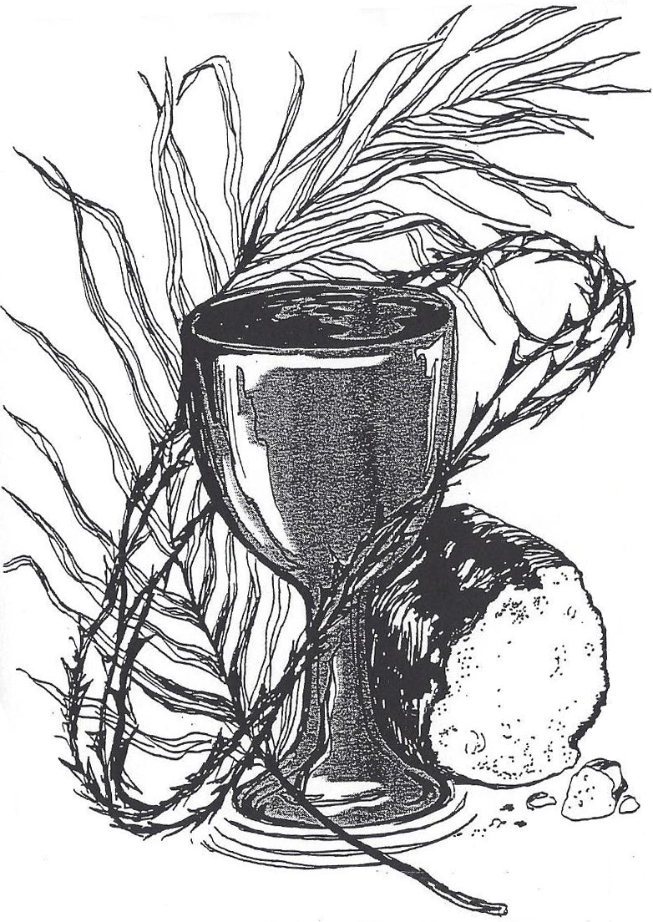

Called by God
to be the heart, voice, hands and feet of
Christ where the Spirit leads us.

Service for the Lord’s Day
Tuckahoe Presbyterian Church

September 9, 2018 23rd Sunday in Ordinary Time
*****************************************************************************

Welcome and Announcements

Music Meditation

*Call to Worship
We are gathered to celebrate life’s great gifts—
To worship the Lord who is the source of them all:
That the ears of us deaf may be opened—
To hear the words of truth and beauty;
That the tongues of us mute may be loosed –
To speak the words of love and duty.
The Lord seeks us. Come, let us seek the Lord.

*Hymn “O for a Thousand Tongues to Sing” No. 610

Prayer of Confession

Assurance of Pardon

*Gloria Patri
Glory be to the Father, and to the Son, and to the Holy Ghost. As it was in the beginning, is now and ever shall be, world without end. Amen. Amen

*Passing of the Peace
The peace of our Lord Jesus Christ be with you all.
And also with you!

Dedication of Music and Formational Ministries

Prayer for Illumination
Healing God, you do all things well. Illumine our hearts by your Holy Spirit, that we may receive your words and demonstrate your grace. Amen.

Old Testament Lesson Proverbs 22: 1 - 2, 8 - 9, 22 - 23 Page 604
The word of the Lord
Thanks be to God.

Gospel Lesson Mark 7: 24 - 37 Page 42
The word of the Lord.
Thanks be to God.

Moments with the Children Sarah Dennis

*Hymn “Jesu, Jesu, Fill Us with Your Love” No. 203

Epistle Lesson James 2: 1 – 17 Page 229
The word of the Lord.
Thanks be to God.

Meditation “Worth the Risk“ Patrick Dennis

*Affirmation of Faith – The Nicene Creed Page 34

Presentation of Gifts and Offerings

Offertory

*Doxology No. 606

*Prayer of Thanksgiving and Dedication

Anthem of Preparation “Remember Me” Grier/Everson

Sacrament of Holy Communion
Invitation
Prayer of Thanksgiving
The Lord be with you.
And also with you.
Lift up your hearts.
We lift them to the Lord.
Let us give thanks to the Lord our God
It is right to give our thanks and praise.
…and the heavenly choir:
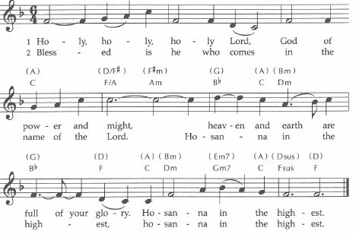
….as we share this joyful feast.
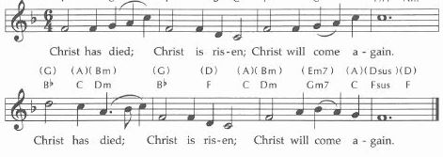

Our Father in heaven, hallowed be your name, your kingdom come, your will be done, on earth as in heaven. Give us today our daily bread. Forgive us our sins as we forgive those who sin against us. Save us from the time of trial and deliver us from evil. For the kingdom, the power, and the glory are yours now and forever. Amen.
Words of Institution
Communion of the people
Prayer After Communion

*Hymn “For Everyone Born” No. 769

*Charge and Benediction

Postlude “The Creation” Haydn

announcements and calendar

Today’s Worship Leaders are Patrick Dennis, Pastor; Diane Prevary, Parish Associate; Linda Kurtz, Seminary Intern; Mark Cain, Director of Music Ministries; Sarah Cothern, Assistant Director of Music Ministries; Terry Brady, Lay Reader; and Courtney Fabian, Acolyte.

We welcome our visitors today and invite you to join us in Duntreath Hall following worship for refreshments and a chance to get to know each other. Please sign the Friendship Pads when they are passed in the pews. If you are visiting Tuckahoe for the first time, please see an usher in the narthex to receive a gift.

The flowers are given by Dave and Kathy Bauer to the Glory of God and in honor of Louisa and Clara Van Rompay and Susie Willis. Nursery helpers are Logan Albertson, Heather DeBolt and Pat Miller. The sound technician is Jay Guller. The After-Worship Fellowship Time is hosted by the Fellowship Committee.

Pastoral Care Concerns:
Hospitalized and recovering: Dick Dawes, Corinne Schill, and Bob Smith

Please plan to stay for a special reception following worship today in Duntreath Hall to celebrate the 100th birthday of Richard Cavendish!

Today we welcome our new seminary intern, Linda Kurtz, to the worship and work of Tuckahoe. Linda is in her final year at Union Presbyterian Seminary, where she is completing Master of Divinity and a Master of Arts in Christian Education degrees.

A new member class will be offered on Sunday mornings at 9:30 a.m. in the church parlor, October 28 – November 18. If you are interested in learning about what it means to be a member of our church, please contact Pastor Dennis via email at pdennis@tuckahoepres.org or by calling the church office at 804-282-2860.

This morning we collect our monthly food donations for Henrico’s food pantry, The Lamb’s Basket. Please place your non-perishable food donations in the collection bin on the left side of the cabinets in the Resource Center. Remember to only place sealed containers—preferably cans and glass containers to deter mice.

The Session has called a congregational meeting for Sunday, September 23 following worship to act on a report from the Church Officer Nominating Committee and vote on incorporation. For informational purposes, Tim Beane will be available on Sunday, September 16th, following worship in Room 106 to answer members’ questions about incorporation.

Childcare is provided during the worship hour for children infant through first grade. The Nursery in Room 104 is designed for infants through 23 months. Two and three year olds may be taken to Room 102. Children age 4 through 1st grades may be taken to Room 105 for childcare. Parents are responsible for picking up children from childcare at the conclusion of the service.

Youth Group Kick-Off is tonight! Retreats, missions, learning about Jesus, and lots of fun--that is what is in store for Youth Group 2018-2019! The youth advisors have been planning and praying for the amazing year we have in store. Our program will be from 5:30-6:30, with a potluck dinner beginning at 6:30 pm. A parents’ meeting will be held at 5:30 pm tonight and all parents are invited to stay for games and for dinner at 6:30.

Our weekly Prayer group meets each Tuesday at 9:30 a.m. in the church parlor. The group is studying the book, A Guidebook to Prayer: 24 Ways to Walk with God, by Mary Kate Morse. All are welcome as we join our hearts together in prayer for our church, our community and the world.

Wednesday Night Suppers resume this week with dinner at 6:00 pm in Duntreath Hall. This year our programing will vary, so stay tuned to know each week’s programs. This week Cooking Team 5 brings back the “Tuckahoe Diner” with a menu of burgers, hot dogs, grilled onions, tater tots and ice cream sandwiches. Linda Kurtz, our Seminary Intern for 2018-19, will be our speaker and will share her story with us. KMD Bells and TChime6 children’s chime group will rehearse during the program time each week.

Wouldn’t you love a night out without having to think about a babysitter? We are starting a Parents Night Out once a month at Tuckahoe, on the second Friday of the month from 6 – 9:00 p.m. The first PNO will be this Friday, September 14th. The catch is, two families will be the babysitters each month. So you watch the kids one month, and the other months’ you get a night out! We would like to encourage you all to sign up for a month, and to think about signing up with another couple you don’t know that well so we can nurture new relationships. The families in charge of babysitting will provide dinner for the kids that night. Childcare will be here at Tuckahoe, so there can be movies, games and playground time. Use this link to sign up to “host” the childcare: www.SignUpGenius.com/go/5080E49A5AC22A2FA7-parents.

Camp Hanover is having a Living Life Abundantly, one day retreat on September 27 from 8 am to 3 pm. Rev. Denise Anderson, General Assembly co-moderator 2016-2018 is speaking on the church today and what we need to do as we head into the future. The registration fee is $20 and includes a continental breakfast, hearty lunch and devotion. For more information and to register go to: presbyteryofthejames.com/fall-retreat . Registration is due by September 20th.

Staying Connected, with a Ministry of Presence. There are many people in our congregation who would benefit from visits and phone calls beyond what the Deacons, Stephen Ministers, Patrick and Ginger can do. We are looking for members who would be willing to have one or two people that they would keep in touch with, develop a stronger friendship with, and be a listening ear for, when needed. God created us to be in relationships! We will meet with those who are interested to begin this endeavor. Call or email Ginger at (804) 399-0081 or gspence@tuckahoepres.org.

LECTIONARY FOR NEXT SUNDAY, SEPTEMBER 16:
Proverbs 1:20-33, Psalm 19:1-14, James 3:1-12
l Mark 8:27-38

THIS WEEK AT TUCKAHOE

Sunday, September 9
9:30 | AM |  | Sunday School
11:00 | AM |  | Worship & Communion
After Worship Fellowship Time in Duntreath Hall
5:30 | PM |  | Youth Group Kick-Off – Duntreath Hall
Monday, September 10 Office hours 9:00 a.m. – 3:00 p.m.
12:00 | PM |  | Men’s Lunchtime Bible Study – Room 108
1:00 | PM |  | FeedMore Donation Group
7:00 | PM |  | Outreach Committee – Room 108
Tuesday, September 11 Office hours 9:00 a.m. – 3:00 p.m.
9:30 | AM |  | Morning Prayer Group – Church Parlor
5:30 | PM |  | Emergency Shelter Meal
5:45 | PM |  | Endowment Committee - Workroom
7:00 | PM |  | Stewardship & Finance Committee - Workroom
Wednesday, September 12 Office hours 9:00 a.m. – 3:00 p.m.
9:30 | AM |  | Staff Meeting - Workroom
6:00 | PM |  | Wednesday Night Supper
6:30 | PM |  | KMD Bells, TChime 6 rehearsal – Bell Room
7:00 | PM |  | Adult Handbells – Bell Room
7:00 | PM |  | Property Committee - Workroom
7:00 | PM |  | Worship Committee – Room 106
Thursday, September 13 Office hours 9:00 a.m. –3:00 p.m.
7:30 | PM |  | Chancel Choir – Room 210
Friday, September 14 Church Office Closed
120:30 | AM |  | Meals on Wheels
6:00 | PM |  | Parents Night Out @ Tuckahoe
Sunday, September 16
9:30 | AM |  | Sunday School
11:00 | AM |  | Worship
After Worship Fellowship Time – Duntreath Hall
12:30 | PM |  | Fellowship Committee – Room 108
5:30 | PM |  | Youth Group – Duntreath Hall


TUCKAHOE PRESBYTERIAN CHURCH
7000 Park Avenue, Richmond, VA 23226
804-282-2860; www.tuckahoepres.org

