TUCKAHOE PRESBYTERIAN CHURCH

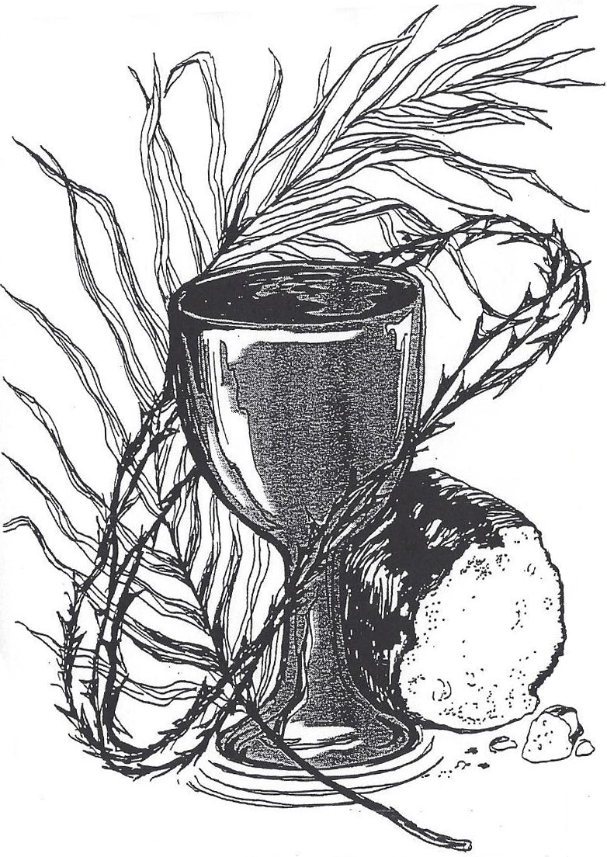

Called by God
to be the heart, voice, hands and feet of
Christ where the Spirit leads us.

Service for the Lord’s Day
Tuckahoe Presbyterian Church

November 20, 2016 Christ the King Day
****************************************************************************
Welcome and Announcements

Stewardship Moment Bill Carter

Music Meditation

Call to Worship
Blessed is the Lord our God,
who has sent us a mighty Savior.
Blessed is the Lord Jesus Christ,
who reigns in glory forever.
Let us worship God.

Prayer of the Day

*Hymn “We Gather Together” No. 336

*Prayer of Confession
Righteous God,
you have crowned Jesus Christ as Lord of all.
We confess that we have not bowed before him,
and are slow to acknowledge his rule.
We give allegiance to the powers of this world,
and fail to be governed by justice and love.
In your mercy, forgive us.
Raise us to acclaim him as ruler of all,
that we may be loyal ambassadors, obeying the commands of our Lord Jesus Christ. Amen. …(silent confession)

*Gloria Patri
Glory be to the Father, and to the Son, and to the Holy Ghost. As it was in the beginning, is now and ever shall be, world without end. Amen. Amen.

*Passing of the Peace
The peace of our Lord Jesus Christ be with you all.
And also with you!

Prayer for Illumination

Gospel Lesson John 9: 35 - 41 Page 103
This is the Word of the Lord. Thanks be to God.

Old Testament Lesson I Samuel 16: 1 - 13 Page 259
This is the Word of the Lord. Thanks be to God.

Communion Meditation “Unlikely King” Patrick Dennis

*Affirmation of Faith -Nicene Creed Hymnal - page 34

Presentation of Gifts and Offerings

Offertory “Give Thanks” Smith

*Doxology and Prayer of Dedication

Moments with the Children

*Hymn of Preparation “Break Thou the Bread of Life” No. 460

Sacrament of Holy Communion
Invitation
Prayer of Thanksgiving
The Lord be with you.
And also with you.
Lift up your hearts.
We lift them to the Lord.
Let us give thanks to the Lord our God
It is right to give our thanks and praise.
…joining the song of the universal church and the heavenly choir:
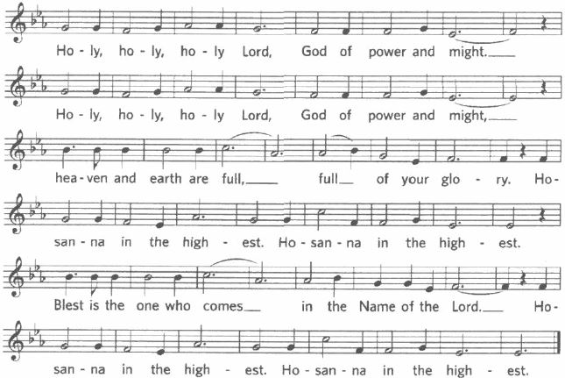

… as we share this joyful feast.
Christ has died, Christ is risen, Christ will come again.
The Lord’s Prayer Ecumenical
Our Father in heaven, hallowed by your name, your kingdom come, your will be done, on earth as in heaven. Give us today our daily bread. Forgive us our sins as we forgive those who sin against us. Save us from the time of trial and deliver us from evil. For the kingdom, the power, and the glory are yours now and forever. Amen.
Distribution of the Elements
Prayer After Communion

*Hymn “Now Thank We All Our God No. 643

*Charge and Benediction

*Response “I Love to Tell the Story” – Refrain
I love to tell the story; ‘twill be my theme in glory
to tell the old, old story of Jesus and his love.

*Postlude “Voluntary on ‘Kremser’” Young

*Assurance of Pardon
…In the name of Jesus Christ, we are forgiven!
Thanks be to God.

ANNOUNCEMENTS AND CALENDAR

Today’s Worship Leaders are Patrick Dennis, Pastor; Diane Prevary, Parish Associate; Sarah Dennis, Director of Christian Formation; Mark Cain, Director of Music Ministries; Sarah Cothern, Assistant Director of Music Ministries; Emily Theuer, Lay Reader.

We welcome our visitors today and invite you to join us for refreshments in Duntreath Hall after the service so we can get acquainted. Please sign the Friendship Pads when they are passed in the pews. If you are visiting Tuckahoe for the first time, please see an usher in the narthex to receive a gift. We invite those of you who are interested in joining the church to contact Pastor Dennis so we can include you in the new member’s class beginning in December.

The flowers are given by Eileen and Bill Vogel to the Glory of God and in memory of their loving parents. Nursery helpers are William Adair, Meg Packard and Kerry Barksdale. The acolyte is Dylan Berriman.

Join us following worship today for our “Thankful Traditions” lunch, sponsored by the Fellowship Committee! We will share our favorite family traditional dishes and fellowship around tables together and celebrate all we have to be thankful for!
Remember in your prayers these members of our Tuckahoe family in need of God’s healing mercies: Mary Lane Brockenbrough, Jean Bynum, Joan Clement and Doris Tate.

Childcare is provided during the worship hour for children infant through first grade. The Nursery in Room 104 is designed for infants through 23 months. Two and three year olds may be taken to Room 102. Children age 4 through 1st grades may be taken to Room 105 for childcare. Parents are responsible for picking up children from childcare at the conclusion of the service.

There is no Wednesday Night Supper this week. Enjoy this special time of the year with your family! Our regular meals will resume on Wednesday, November 30th with a covered dish supper at 6:00 p.m. in Duntreath Hall. Programming following dinner resumes on March 8. Please sign up on the friendship pads next Sunday, November 27th or call the church office by Monday, November 28th to let us know how many to expect.

A Service of Healing and Wholeness with the theme of “Blue Christmas” will be held in our sanctuary on next Sunday, November 27 at 4:00 p.m. Those looking for comfort, hope, wholeness, and renewal for themselves or others are encouraged to come for prayer, contemplation and restful silence.

The Angel Tree will be up in the Fellowship Hall next Sunday, November 27 and December 4, please pick an Angel from the tree to make Christmas special for a lucky child and return your gift by December 11th. We have been working through the Ministry of Prison Fellowship “Angel Tree” project for many years to help incarcerated men and women provide Christmas presents to their children who live in metropolitan Richmond. These presents provide a tangible reminder to the children that their parent loves them even though they cannot be with them at Christmas. Each child will receive two gifts: one toy and one clothing item. We need many members of the congregation to purchase and gift wrap one gift each (approx. $20-$25). The gifts have been selected by the parents, so you can be sure they will be appropriate and appreciated. We also need people to assist with the delivery of the presents to the children the week before Christmas. Contact Pam Burch at 364-5203 or vaburch@comcast.net with questions.

Mark your calendars for Sunday afternoon, December 4th at 3:00 p.m. for an Advent Workshop for all ages! Meet in Duntreath Hall for crafts, music, cooking-making and more. This is a great opportunity to spend time with your extended church family as we get in the spirit of the Advent season!

Plan to attend the very special worship service on Sunday, December 18 when Tuckahoe’s Chancel Choir, accompanied by a 10-piece orchestra, will present a Christmas Choral performance of Mary McDonald’s “Jesus! The Advent of the Messiah” during the worship service. You won’t want to miss this service of inspiring music. Plan to bring your whole family to experience the joy of music and voices lifted in celebration of the season.

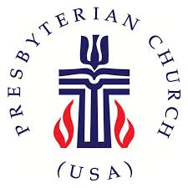
LECTIONARY TEXT FOR THIS SUNDAY:
Jeremiah 23:1-6; Luke 1:68-79; Colossians 1:11-20; Luke 23:33-43

Next Week’s the Story Reading:
Chapter 12 – The Trials of a King
II Samuel 11 – 19; 1 Chronicles 22,29

Need more information about Tuckahoe, our mission, ministries and events? Just scan the QR code below with your smartphone and you’ll be directed to our church website!


TUCKAHOE PRESBYTERIAN CHURCH
7000 Park Avenue, Richmond, Virginia 23226
804-282-2860; www.tuckahoepres.org

This WEEK AT TUCKAHOE
Sunday, November 20
9:30 | AM |  | Sunday School
11:00 | AM |  | Worship & Communion
After Worship Thankful Traditions Luncheon – Duntreath Hall
6:00 | PM |  | Youth Groups – Duntreath Hall
Monday, November 21 Office hours 9:00 a.m. – 3:00 p.m.
Tuesday, November 22 Office hours 9:00 a.m. – 3:00 p.m.
3:30 | PM |  | Hilliard House Meal
7:00 | PM |  | Administration & Personnel Committee - Workroom
Wednesday, November 23 Office hours 9:00 a.m. – 3:00 p.m.
9:30 | AM |  | Staff Meeting - Workroom
Thursday, November 24 OFFICE CLOSED
Friday, November 25 Office closed
Sunday, November 27
9:30 | AM |  | Sunday School
11:00 | AM |  | Worship
After Worship |  |  | Fellowship Time – Duntreath Hall
4:00 | PM |  | Service of Healing & Wholeness - Sanctuary

